White Board Experience For Project 4

David Olson

CS 312, Martinez Section 2

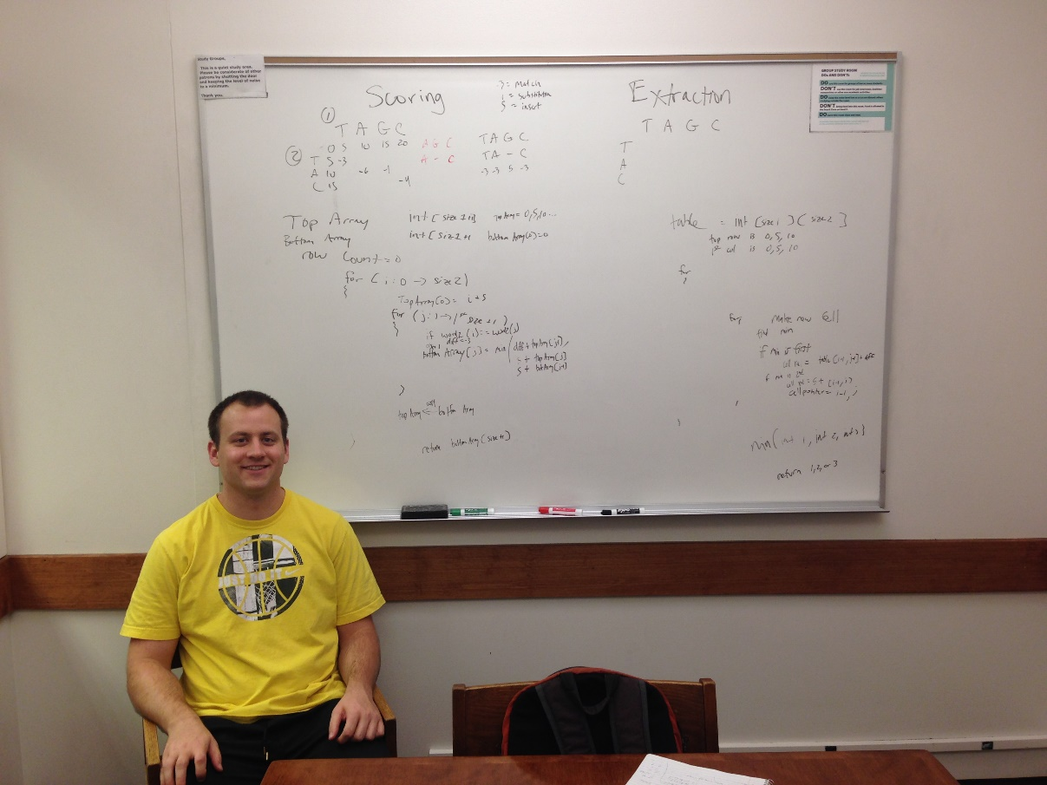

We finally got ourselves a decent setup this time by reserving a study room in the HBLL. There I am in bright yellow, can’t miss me. On the board you will see (other than study room etiquette of course) the scoring algorithm to the left, which makes use of 2n space by using only two arrays. On the right is the extraction algorithm that uses an n^2 array to store values and back pointers, but that way we can actually know what the alignment is. Other functions are possibly a diff function and definitely a min function. Yes there are some details left out, but you’ll have to remember a lot of my teaching was verbal and my whiteboard partner and I do love our semi-pseudocode.